EXPERIMENT – 7
STEP-WISE SOLUTION
Title: Integration of Advanced Analytics with BI Reports using Microsoft Power BI

Aim
To integrate advanced analytics with Business Intelligence reports, analyze business performance, identify strengths, weaknesses and opportunities, and prepare data-driven recommendations using the Experiment 7 Power BI dashboard.

Software / Requirements
- Microsoft Power BI Desktop (Windows environment required to open and edit PBIX files).
- Experiment7.pbix – the supplied Experiment 7 report.
- Microsoft Word for the Business Insight Report.
- Microsoft PowerPoint for the 5–7 slide executive presentation.

Overview of the Supplied Experiment 7 PBIX
The supplied PBIX report definition contains four report pages and 50 visual objects in total. The page names and main visual titles below are taken from the supplied file.
Page | Visuals / analytical content
01 | Executive Dashboard | Region, Category and Year slicers; Total Sales, Total Profit, Total Orders and Profit Margin cards; Sales by region; Sales by category; Monthly sales trend; Top 10 customers by sales; Profit by segment; scorecard with illustrative target (previous year +10%); customer and operational context card.
02 | Growth & Margin | Region, Category and Year slicers; KPI cards; Annual sales; Annual profit margin; Monthly sales; Yearly comparison.
03 | Profit Drivers | Region, Category and Year slicers; Total Sales, Total Profit, Profit Margin and Gross Loss cards; Profit by sub-category; Profit margin by category; Regional profit margins.
04 | Discounts & Segments | Region, Category and Year slicers; Average Discount, Loss Lines, Loss Line Share and Gross Loss cards; Net profit by discount band; Sales by discount band; Discount evidence table; Customer segment margin.
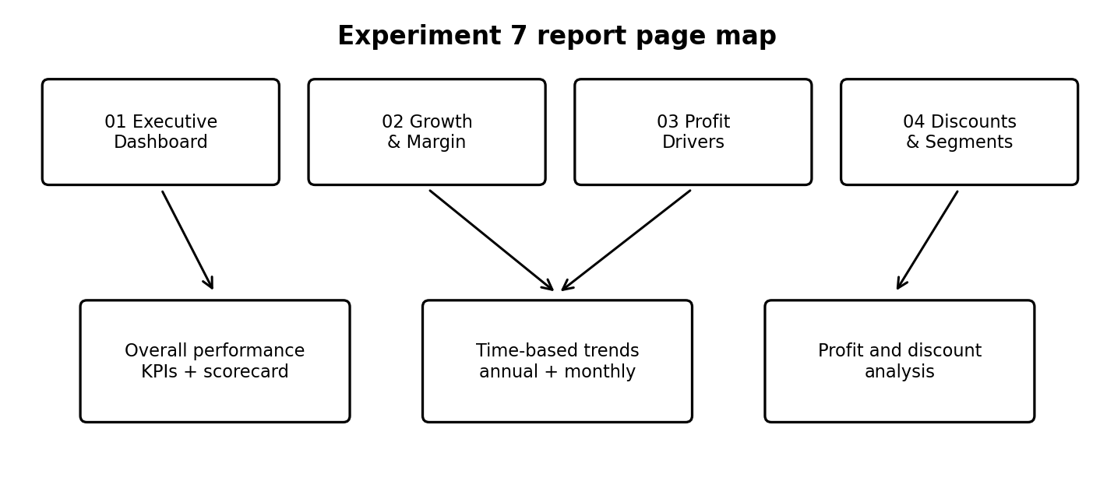
Figure 1: Page map of the supplied Experiment 7 report.

Procedure

Part A – Open the Experiment 7 Report
- Start a Windows computer or Windows virtual machine with Microsoft Power BI Desktop installed. A native macOS version of Power BI Desktop is not available.
- Open Power BI Desktop and select File → Open report (or Browse reports).
- Select the supplied file named Experiment7.pbix.
- Wait for the report to load. If Power BI displays a security, data source, or credential prompt, review it and provide the appropriate access if you have it.
- Confirm that the four pages appear in the report page navigation. Do not overwrite the original file; use Save As to create a working copy if you plan to edit it.
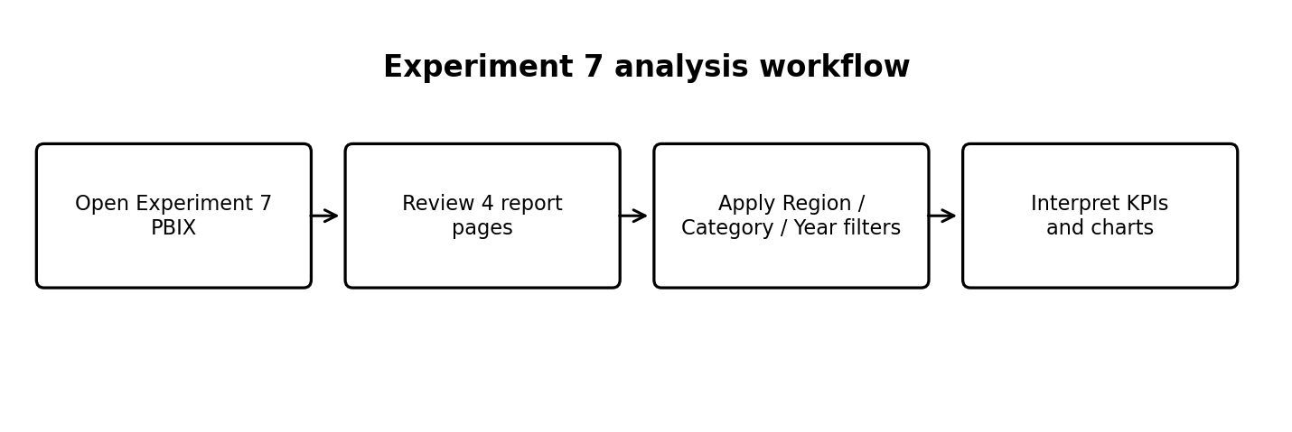
Figure 2: General workflow for reviewing and analyzing Experiment 7.

Part B – Analyze Page 01: Executive Dashboard
- Open the page named 01 | Executive Dashboard.
- Review the KPI cards: Total Sales, Total Profit, Total Orders and Profit Margin. Record the displayed values and reporting period in your observation sheet.
- Use the Region, Category and Year slicers one at a time. Observe how the KPI cards and charts respond.
- Study Sales by region. Compare sales across regions and, where profit information is available elsewhere in the report, avoid judging performance by sales alone.
- Study Sales by category and Profit by segment. Note the categories and segments with relatively high or low values as actually shown.
- Review Monthly sales trend for peaks, declines and recurring patterns.
- Review Top 10 customers by sales. Confirm the visual shows no more than ten customer names and that the ranking is based on sales.
- Review the scorecard. The title states that its target is illustrative (previous year +10%); do not describe this as an official company target unless separately verified.
- Capture a screenshot of the complete dashboard and close-up screenshots of important visuals.

Part C – Analyze Page 02: Growth & Margin
- Open 02 | Growth & Margin.
- Review the KPI cards for Total Sales, Total Profit, Profit Margin and Total Orders.
- Study Annual sales to compare performance across years.
- Study Annual profit margin to see whether profitability is improving or weakening over time.
- Study Monthly sales to identify high- and low-performing months.
- Review the Yearly comparison table and cross-check its values against the annual charts.
- Apply the same Region, Category and Year selections used on Page 01 when making comparisons, so the analysis uses a consistent filter context.
- Record whether sales and profit margin move in the same direction or show a divergence.

Part D – Analyze Page 03: Profit Drivers
- Open 03 | Profit Drivers.
- Review Total Sales, Total Profit, Profit Margin and Gross Loss cards.
- Study Profit by sub-category. Identify sub-categories with comparatively strong profit and those with low or negative profit.
- Study Profit margin by category. Compare margin rather than sales volume alone.
- Study Regional profit margins to identify regional differences in profitability.
- Use Region, Category and Year slicers to investigate whether the pattern changes under different selections.
- Record the strongest and weakest areas only after checking the actual chart values and labels.

Part E – Analyze Page 04: Discounts & Segments
- Open 04 | Discounts & Segments.
- Review Average Discount, Loss Lines, Loss Line Share and Gross Loss cards.
- Study Net profit by discount band. Compare profit across discount ranges.
- Study Sales by discount band. Check whether higher sales in a discount band are accompanied by healthy net profit.
- Review the Discount evidence table for the detailed values available in the report.
- Study Customer segment margin and compare the profit margin across customer segments.
- Apply slicers to check whether discount and segment patterns differ by region, category or year.
- Do not conclude that discounts caused a loss based only on correlation; describe the observed relationship and recommend further review.

Part F – Convert Analysis into Business Insights
Use the following evidence-based method. Each finding must be supported by a value, comparison, chart, or table from the actual Power BI report.
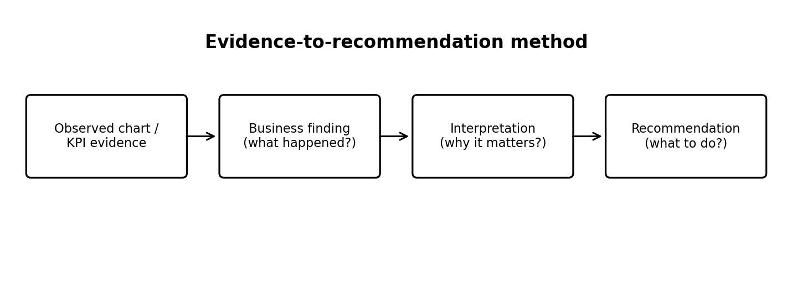
Figure 3: Move from chart evidence to a business recommendation.
Required section | What to write | Evidence to use
Business strengths | At least two areas performing relatively well. | High sales/profit/margin in the relevant regional, category, segment or trend visual.
Business weaknesses | At least two areas needing attention. | Low or negative profit, weak margin, loss-line measures, or sales/profit divergence.
Business opportunities | At least two realistic areas for improvement. | Potential to improve discount policy, product mix, regional focus, segment strategy or seasonal planning.
Recommendations | Actions linked directly to identified findings. | State the finding, supporting visual/KPI, proposed action and expected business benefit.

Part G – Prepare the Business Insight Report
- Create a Word document titled Business Insight Report – Global Superstore.
- Write the objective of analysis and list the four Experiment 7 report pages reviewed.
- Add a Key Findings section covering regional sales, category profitability, customer segments, monthly/yearly trends, profit drivers and discount patterns.
- Add separate sections for Business Strengths, Business Weaknesses, Opportunities for Improvement, Recommendations and Conclusion.
- Insert screenshots from the actual Power BI report. Add a short caption below each screenshot.
- Include numerical values only after reading them from the report. Mention the filters (Region, Category and Year) used for each comparison.
- Check that each recommendation is linked to at least one verified finding.

Part H – Prepare the Executive Presentation
Slide | Suggested content
1. Introduction | Business scenario, objective and analysis scope.
2. Dashboard overview | Screenshot of Executive Dashboard and main KPIs.
3. Key findings | Regional sales, category profitability and customer segment performance.
4. Growth and profit drivers | Annual/monthly trends, sub-category profit and regional margins.
5. Discount and segment insights | Discount-band analysis, loss indicators and customer segment margin.
6. Recommendations | Prioritized actions supported by dashboard evidence.
7. Conclusion | Summary of business implications and next steps.

Part I – Recommendation Summary Sheet
Prepare a one-page table with these columns: Business issue or opportunity; evidence from Power BI; recommended action; expected benefit; priority. Include only issues supported by the actual report.

Part J – Save and Submit
- Save the Business Insight Report as DOCX and export a PDF copy if required.
- Save the executive presentation as PPTX and export a PDF copy if required.
- Save the recommendation summary sheet.
- If you edit the Power BI report, save the working copy as Experiment7_Final.pbix. Keep the original Experiment7.pbix unchanged.
- Reopen the saved files and check that report pages, screenshots, tables and text are readable.
- Submit the PBIX together with the report, presentation and recommendation summary sheet as required by your instructor.

Screenshot Checklist
- Page 01 – Executive Dashboard with KPI cards and charts.
- Page 02 – Growth & Margin with annual and monthly trend visuals.
- Page 03 – Profit Drivers with sub-category, category and regional margin charts.
- Page 04 – Discounts & Segments with discount-band and segment-margin visuals.
- At least one filtered view showing how Region, Category or Year slicers affect the analysis.

Result
The supplied Experiment 7 Power BI report was reviewed page by page. Its executive KPIs, regional and category analysis, customer segment views, growth trends, profit drivers and discount analysis were organized into a step-wise analytical procedure for identifying business insights and preparing recommendations.

Important Notes
- This document is based on the structure and visual titles found in the supplied Experiment7.pbix file. It does not invent numerical findings or DAX formulas.
- The scorecard title identifies its target as illustrative (previous year +10%). Treat it as an illustrative target unless the instructor or business scenario confirms otherwise.
- The diagrams are explanatory illustrations, not screenshots of the live Power BI report.
- The actual calculations, data refresh, visual rendering, slicer interactions and Top 10 logic should be tested in Power BI Desktop before submission.

